***DOFLinx Quicker Guide for V8.12***

Contents

1. Introduction 2

2. Installation 2

3. 32 or 64 bit? 3

4. After its Running 4

5. Building Your Software Installation 4

6. What Should It Look Like 5

7. More Help 6

# Introduction

Over time DOFLinx has grown more powerful with more options. This can make initial setup a bit daunting. While I don’t think I can do a “quick” guide, I think I can achieve a “quicker” guide. For full information see the DOFLinx Guide.

The aim of this guide is to get you a basic installation up and running for Pinball FX and / or MAME on a version of Windows 64 bit. You will need to customise some things as your cabinet is your own.

# Installation

1. Create a folder for DOFLinx, let’s call it C:\DOFLINX
2. Download DOFLinx from here <https://www.vpforums.org/index.php?app=downloads&showfile=12318> into C:\DOFLINX
3. Unblock the downloaded DOFLinx.Vxx.ZIP file
4. Unpack C:\DOFLINX\DOFLinx.Vxx.ZIP into the same folder
5. Copy the premade DOFLinx-Shortcut.lnk to startup  
   To open the startup folder in Windows use Win-R and type in shell:startup  
     
   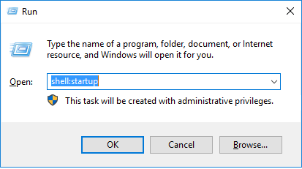  
     
     
   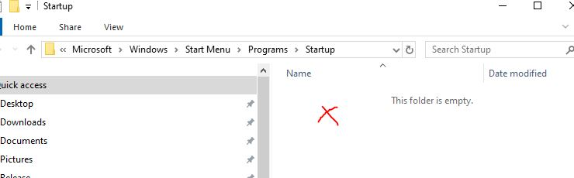  
     
   When Explorer comes up with the startup folder right click in the blank area on the right and paste. This will copy your newly created shortcut for DOFLinx.
6. Run DOFLinxConfig
   1. Check that you do not have any errors and that you understand any warnings
   2. Press the “Configure” button and work through all of your settings

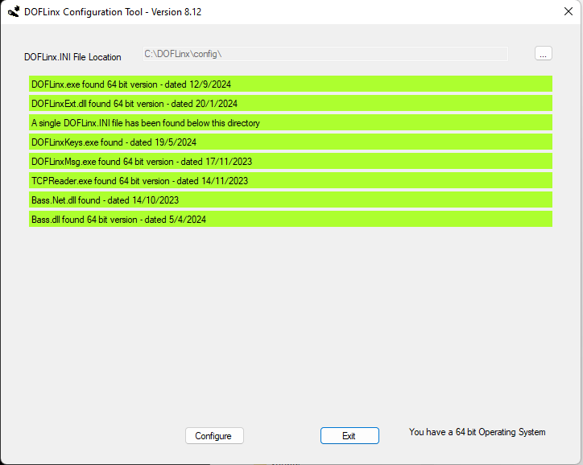

1. Reboot
2. Start Pinball FX or MAME and enjoy

# 32 or 64 bit?

The default installation of DOFLinx above is 64 bit. You must change this to 32 bit only if you have a 32 bit operating system. If you are unsure run DOFLinxConfig and check in the bottom right-hand corner (see image above), it will tell you.

Others may choose to change to a 32 bit installation, that too is fine. DOFLinx 32 bit and 64 bit have identical operation, 64 bit just has access to more memory and is arguable marginally faster.

For those still running some 32 bit pinball tools, please note that your DOFLinx installation does not need to match those. Provided DOFLinx has access to the correct bit sized DirectOutput.dll then it can operate as 64 bit while you run other pinball utilities, even those using DOF, as 32 bit.

To change to 32 bit just copy the contents of \DOFLinx\32 bit into \DOFLinx. To go back to 64 bit do the reverse and copy the contents of \DOFLinx\64 bit to \DOFLinx. If you are unsure if you have it right then run DOFLinxConfig to check. A mixture of 32 and 64 bit will cause some issues.

# After its Running

Once you have a working DOFLinx installation then you may want to do some of these things to make it more enjoyable

1. If you have the Direct Output Framework (DOF) loaded (usually pinball users or MAME cabinet users without output toys), normally located in C:\DirectOutput folder, then delete the DirectOutput.dll file in your C:\DOFLinx folder. This will ensure that DOFlinx uses your current installation and not a local copy of the dll. It will help you out later on when you upgrade DOF.
2. If you have an output device (Dude’s Cab, PinOne, Pinscape, LEDWiz, PacLED, etc) with toys (solenoids, flashers, etc) then run DOFLinxConfig and use “Configure” to setup your toys. Alternatively read the detailed guide and edit your C:\DOFLINX\Config\DOFLinx.INI directly
3. If you’ve got Pinball FX then follow the “Enabling Pinball FX for DOFLinx” guide to get full integration from Pinball FX.
4. If you’ve got MAME then follow the “Guide for Setting up DOFLinx with MAME” guide to get full integration from MAME.

# Building Your Software Installation

Let’s get the software loaded.

1. Install your game.
   1. PinballFX, download the Steam or Epic versions
   2. MAME
      1. Install MAME from here <https://www.mamedev.org/release.html>
      2. Substitute in the MAME_64.exe from here <https://www.vpforums.org/index.php?app=downloads&showfile=16478> to be MAME.exe in your MAME folder (or here if the download size problem hasn’t been fixed yet <https://drive.google.com/drive/folders/1AjJ8EQo3AkmG2mw7w0fLzF9HcOjFoUZH?usp=sharing> )
2. If you are running PinBall FX then install all of the xxx.directb2s files into the folder you pointed to with the PATH_FX_B2S= parameter (default C:\DOFLINX\B2S\) from here <https://drive.google.com/drive/folders/1AjJ8EQo3AkmG2mw7w0fLzF9HcOjFoUZH?usp=sharing>

# What Should It Look Like

Here is a view of my folders all setup. You should end up with something that looks like this.

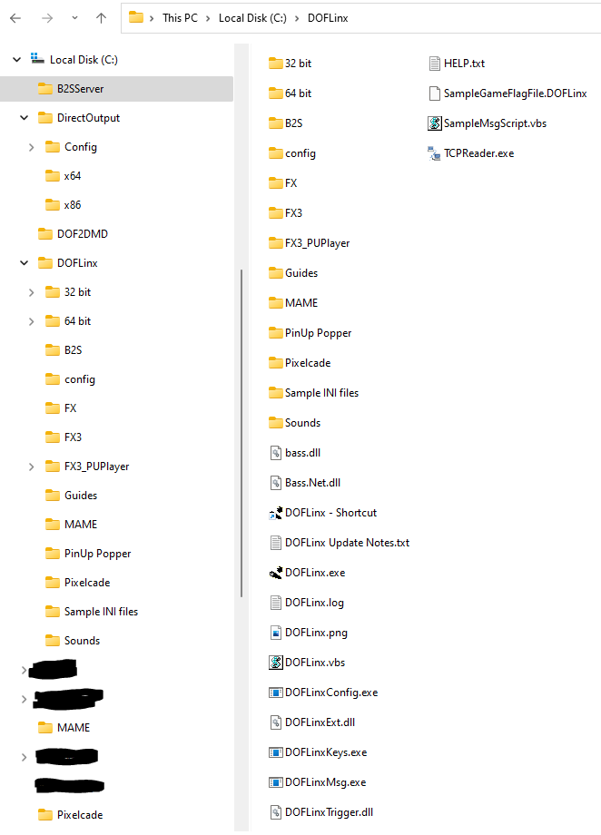

# More Help

Remember, this guide was to try and get you running in the quickest way. For more help

1. Read the full guide
2. Go over to [www.vpforums.org/index.php?showforum=104](http://www.vpforums.org/index.php?showforum=104) and search out your issue. If you can’t find what you are looking for then start a new support thread (be nice and don’t divert an old one unless you have exactly the same issue). I know one of the very knowledgeable and friendly people there will help you out
3. Visit Discord over here <https://discord.com/channels/652274650524418078/652282185889349656>
4. Try to gain an understanding of how things are working, this will allow you to help yourself more often than you think.

Overall, have fun, play games and learn.